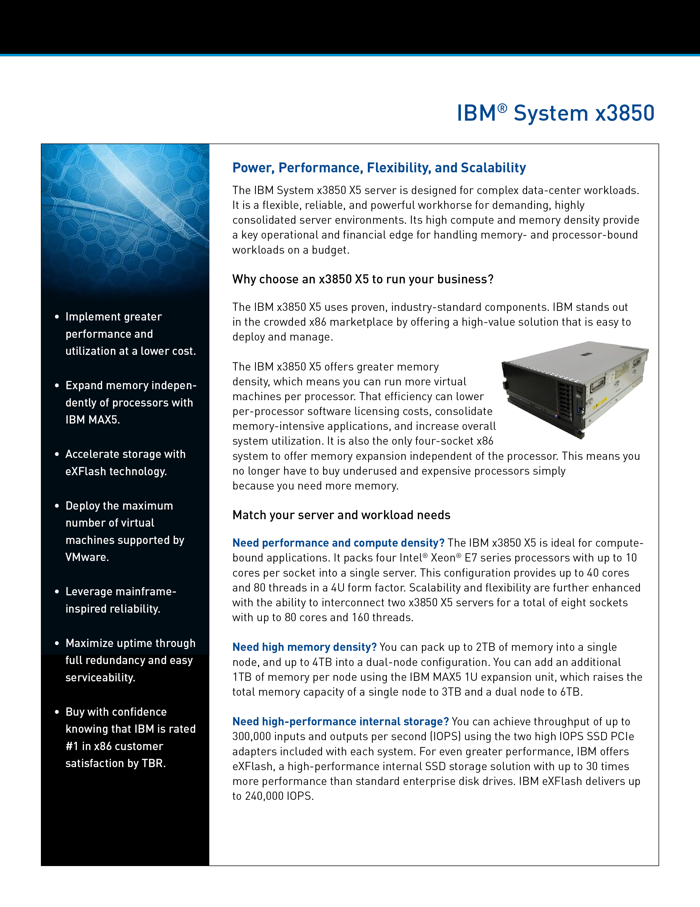

**Partner Logo Here**

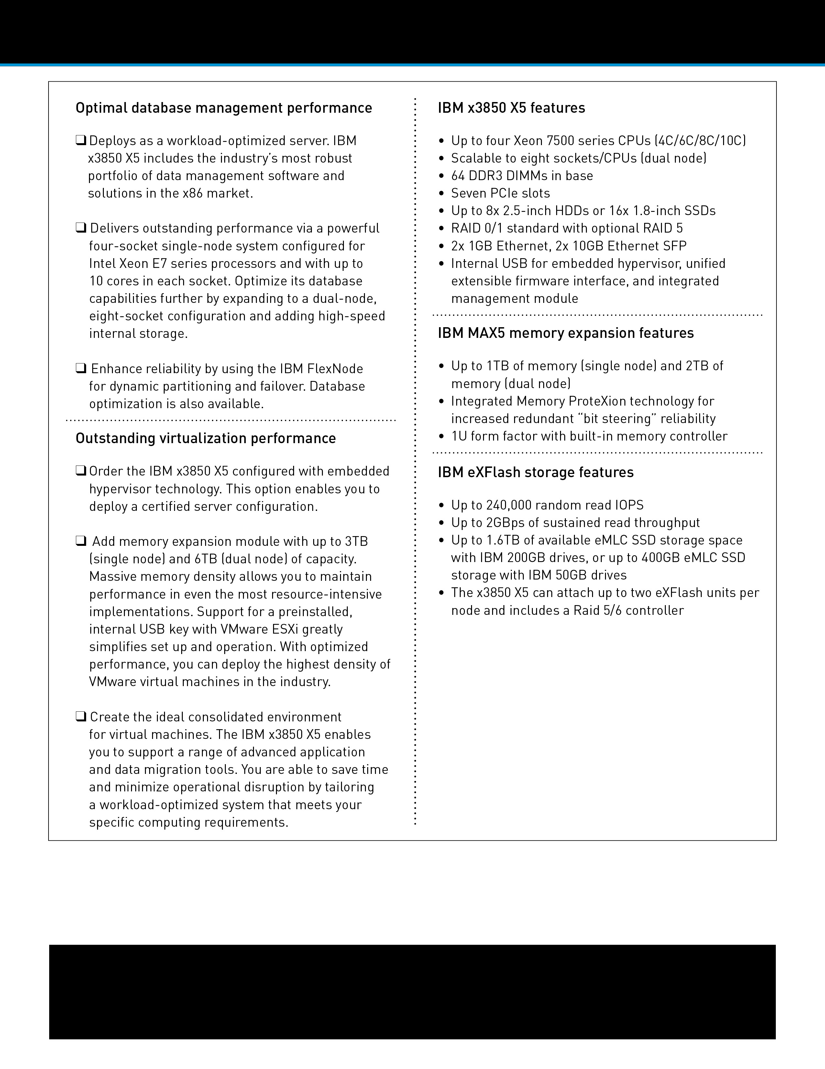

**Partner Logo Here**

***To learn more, contact:  
[insert partner contact information]***